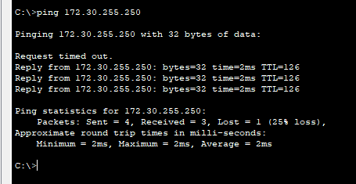!

version 15.1

no service timestamps log datetime msec

no service timestamps debug datetime msec

service password-encryption

!

hostname DATACENTER

!

!

!

enable password 7 08284248060B081606020705

!

!

!

!

!

!

no ip cef

no ipv6 cef

!

!

!

username info password 7 08284248060B081606020705

!

!

license udi pid CISCO1941/K9 sn FTX1524AUV9-

!

!

!

!

!

!

!

!

!

!

!

spanning-tree mode pvst

!

!

!

!

!

!

interface GigabitEthernet0/0

ip address 172.30.255.254 255.255.0.0

duplex auto

speed auto

!

interface GigabitEthernet0/1

ip address 20.20.20.2 255.255.255.252

duplex auto

speed auto

!

interface Serial0/0/0

ip address 10.20.30.2 255.255.255.252

!

interface Serial0/0/1

no ip address

clock rate 2000000

shutdown

!

interface Vlan1

no ip address

shutdown

!

ip classless

ip route 192.168.10.0 255.255.255.128 Serial0/0/0

ip route 172.18.18.0 255.255.255.0 GigabitEthernet0/1

!

ip flow-export version 9

!

!

!

!

!

!

!

line con 0

!

line aux 0

!

line vty 0 4

login local

line vty 5 15

login local

!

!

!

end